**SENTIMENT ANALYSIS OF COVID-19 TWEETS – VISUALIZTION DASHBOARD**

**Submitted By:**

Jeeva K

Sourav R

Abinaya S

Dhivyabharathi S

**ABSTRACT:**

Social media have received more attention nowadays.

Public and private opinion about a w ide variety of subjects are

expressed and spread continually via numerous social media.

Twitter is one of the social media that is gaining popularity.

Twitter offers organizations a fast and effective way to analyze

customers’ perspectives toward the critical to success in the

market place. Developing a program for sentiment analysis is an

approach to be used to computationally

measure customers’ perceptions. This paper reports on the

design of a sentiment analysis, extracting a vast amount of

tweets. Prototyping is used in this development. Results classify

customers’ perspective via tweets into positive and negative

Social media have received more attention nowadays.

Public and private opinion about a w ide variety of subjects are

expressed and spread continually via numerous social media.

Twitter is one of the social media that is gaining popularity.

Twitter offers organizations a fast and effective way to analyze

customers’ perspectives toward the critical to success in the

market place. Developing a program for sentiment analysis is an

approach to be used to computationally

measure customers’ perceptions. This paper reports on the

design of a sentiment analysis, extracting a vast amount of

tweets. Prototyping is used in this development. Results classify

customers’ perspective via tweets into positive and negative

This project addresses the problem of sentiment analysis in twitter that is classifying tweets according to the sentiment expressed in them: positive, negative or neutral. Twitter is a social-networking platform which allows users to write short status updates of maximum length 140 characters. It is a rapidly expanding service with over 200 million registered users - out of which 100 million are active users and half of them log on twitter on a daily basis - generating nearly 250 million tweets per day. Due to this large amount of usage we hope to achieve a reflection of public sentiment by analysing the sentiments expressed in the tweets. Analysing the public sentiment is important for many applications such as firms trying to find out the response of their products in the market, predicting political elections and predicting socioeconomic phenomena like stock exchange. The dashboard provides visibility into the social media discussions around Coronavirus and the quality of information shared on the platform, updated over time. The dashboard maintains an evolving list of corona, COVID19, pandemic, lockdown, lockdown extended, quarantine.

### INTRODUCTION:

### 1.1.OVERVIEW:

Sentiment Analysis of COVID-19 Tweets Dashboard is time taken process to identify the analysis. Using this we can predict the peoples sentiment using the dashboard. In this paper, we construct technique for sentiment analysis of COVID-19 tweets.

**1.2. PURPOSE:**

Our project aims at building a model to predict the helpfulness of the review and the rating based on the review text. Corpus-based and knowledge-based methods can be used to determine the semantic similarity of review text. We used Natural language processing to analyse the sentiment (positive , negative or neutral) of the given review.

1. **LITERATURE SURVEY:**

**2.1. EXISTING PROBLEM:**

Twitter review platform shows the average length of the reviews comes close to 230 characters. Sentiment analysis shows that positive sentiment is prevalent among the reviews and in terms of emotions. So, our task is to create an analysis system capable of analyzing the reviews.

**2.2. PROPOSED SOLUTION:**

We started building a model to predict the helpfulness of the review and the rating based on the review text. Currently audience who write opinion and experience online is increasing. If the audience read the whole review it can spend much times. But if it is read without some evaluation it will be biased. Sentiment classification aims to overcome this problem by automatically classifying user review by positive, negative or neutral opinion.

**3.THEORITICAL ANALYSIS:**

**3.1.BLOCK DIAGRAM:**

**3.2.SOFTWARE DESIGNING:**

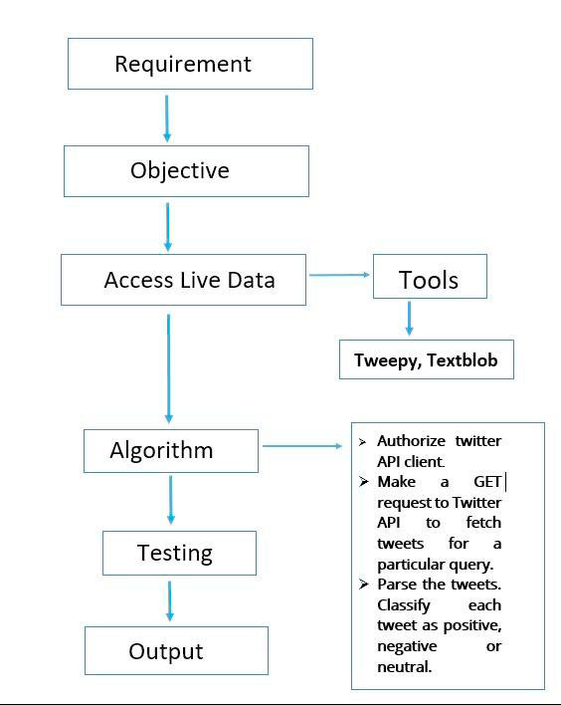

For software we would need a compatible operating system for python, HTML Software needed are:

1) TextBlob

2) Tweepy

3) NLP

4) Google chart

5) HTML

5) CSS

**4.EXPERIMENTAL INVESTIGATION:**

Step 1: Create data files for the classifier.

(1.1) Create a file of tweets with their sentiment of each sentiment analyzer.

(1.2) Save it as csv files

Step 2: Execution of CSV on Twitter File.

(2.1) Load the file of tweets with their labeled sentiment.

(2.2) Apply the StringToWordVector filter .

(2.3) Apply the percentage split approach with 70%.

(2.4) Execute and save the results in the output file.

**5.FLOWCHART:**

POSITIVE

TRAINING DATA SET(POSITIVE, NEGATIVE OR NEUTRAL REVIEWS)

NEUTRAL

OUR SENTIMENT CLASSIFICATION MODEL

REVIEWS

PRE-PROCESSING

NEGATIVE

**6.RESULT:**

The Model analysis and predicts the review and it represents in dashboard whether it is positive, neutral or negative review.

**7.ADVANTAGES AND DISADVANTAGES:**

**Advantages:**

* Easy to display the statistics of real time data.
* Easy to get the sentiment analysis of people from all kind of survey.
* N number of data’s can be used for the analysis.
* Best way of getting the opinion of people about a particular topic.
* Can be used even in small scale industries to understand the opinion of employees and customers.
* It can also be accessible through mobile.

**Disadvantages:**

* We need to keep reviews current and up to date. Otherwise they will seem out of date and irrelevant.
* Sometimes it may not be the complete replacement of reading survey responses.

**8.APPLICATIONS:**

1) Twitter sentiment analysis dashboard allows us to keep track of what's being said about your product or service on social media, and can help you detect angry customers or negative mentions before they turn into a major crisis. At the same time, Twitter sentiment analysis can provide interesting insights.

2) Colleges

3) Hospitals

4) IT industry

5) Feedback analysis of any application

**9.CONCLUSION:**

Nowadays, sentiment analysis or opinion mining is a hot topic in machine learning. We are still far to detect the sentiments of s corpus of texts very accurately because of the complexity in the English language and even more if we consider other languages such as Chinese. In this project we tried to show the basic way of classifying tweets into positive, neutral or negative category using Naive Bayes as baseline and how language models are related to the Naive Bayes and can produce better results. We could further improve our classifier by trying to extract more features from the tweets, trying different kinds of features, tuning the parameters of the naïve Bayes classifier, or trying another classifier all together.

**10.FUTURE SCOPE:**

Sentiment analysis of COVID-19 twitter dashboard minimizes the time of predicting the result. The dashboard predicts and separates the result accurately.

**11.BIBLIOGRAPHY:**

**Proposed Idea:**

<https://towardsdatascience.com/twitter-sentiment-analysis-based-on-news-topics-during-covid-19-c3d738005b55>

**12.APPENDIX:**

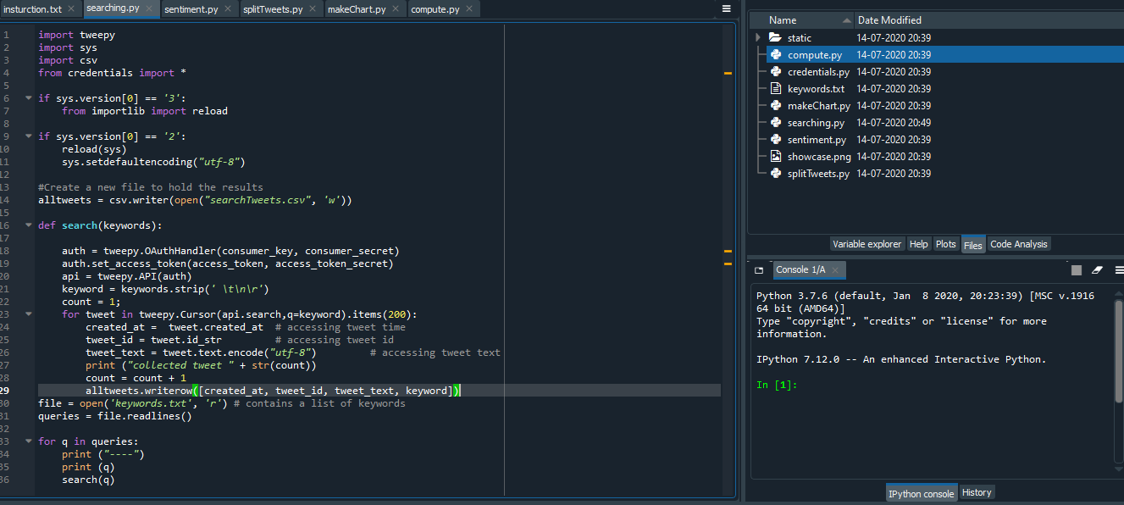

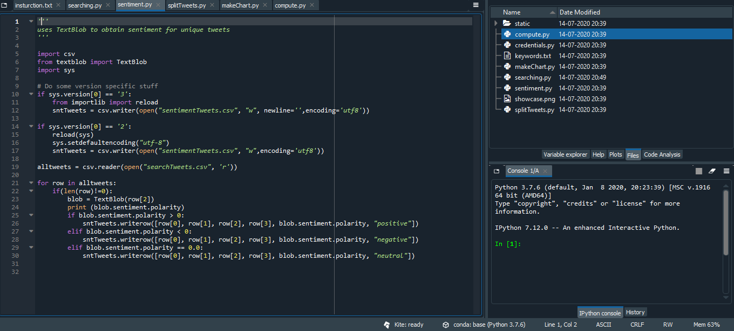

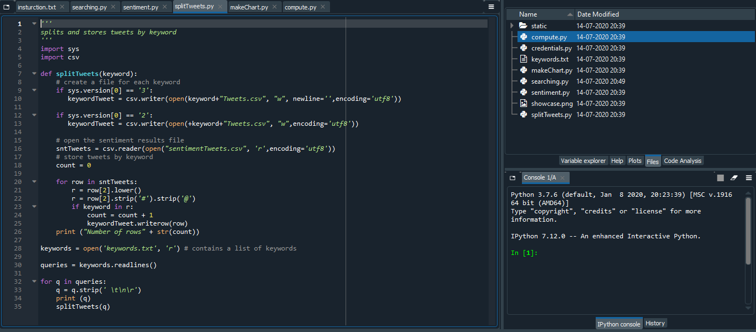

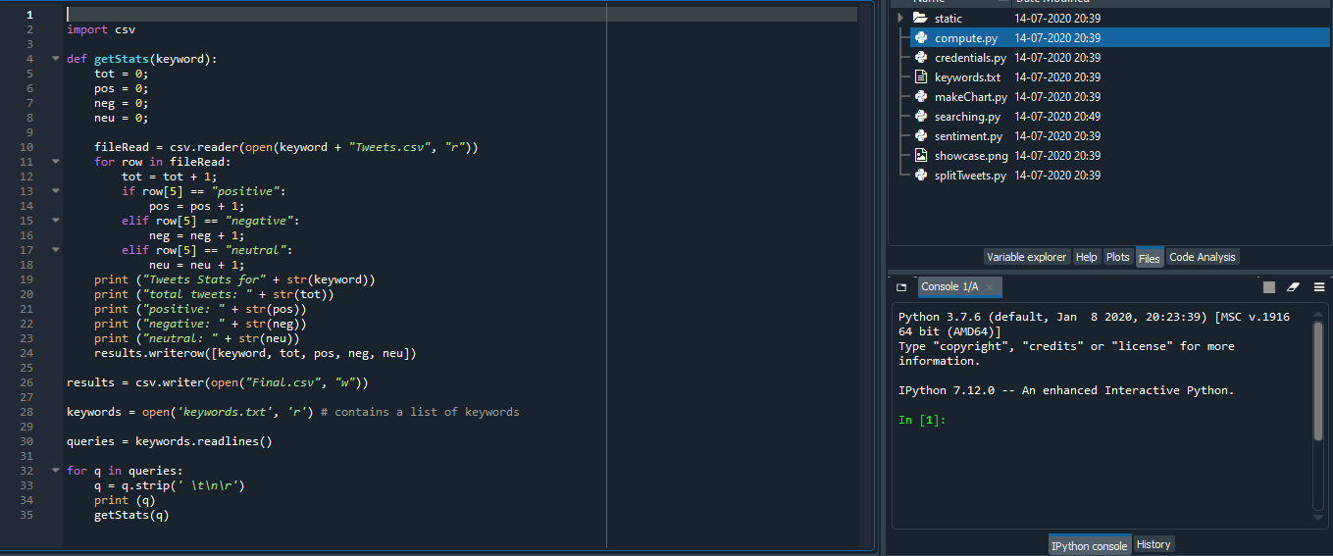

**13.OUTPUT:**



